**Final Project**

Full Task

**Create Course Class with the following features**

* **course_id**
* **course_name**
* **course_class(A-B-C)**

**Create Student Class with this attributes:**

* **student_name**
* **student_id (generated randomly)**
* **studnet_class(A-B-C)**
* **student_couses (List of Courses)**
* **method to add new course to student courses**
  + **the method should check if student_class as same as course_class**
* **method to display student_details**
  + **name**
  + **class**
  + **courses which enrolled**

**Main Page**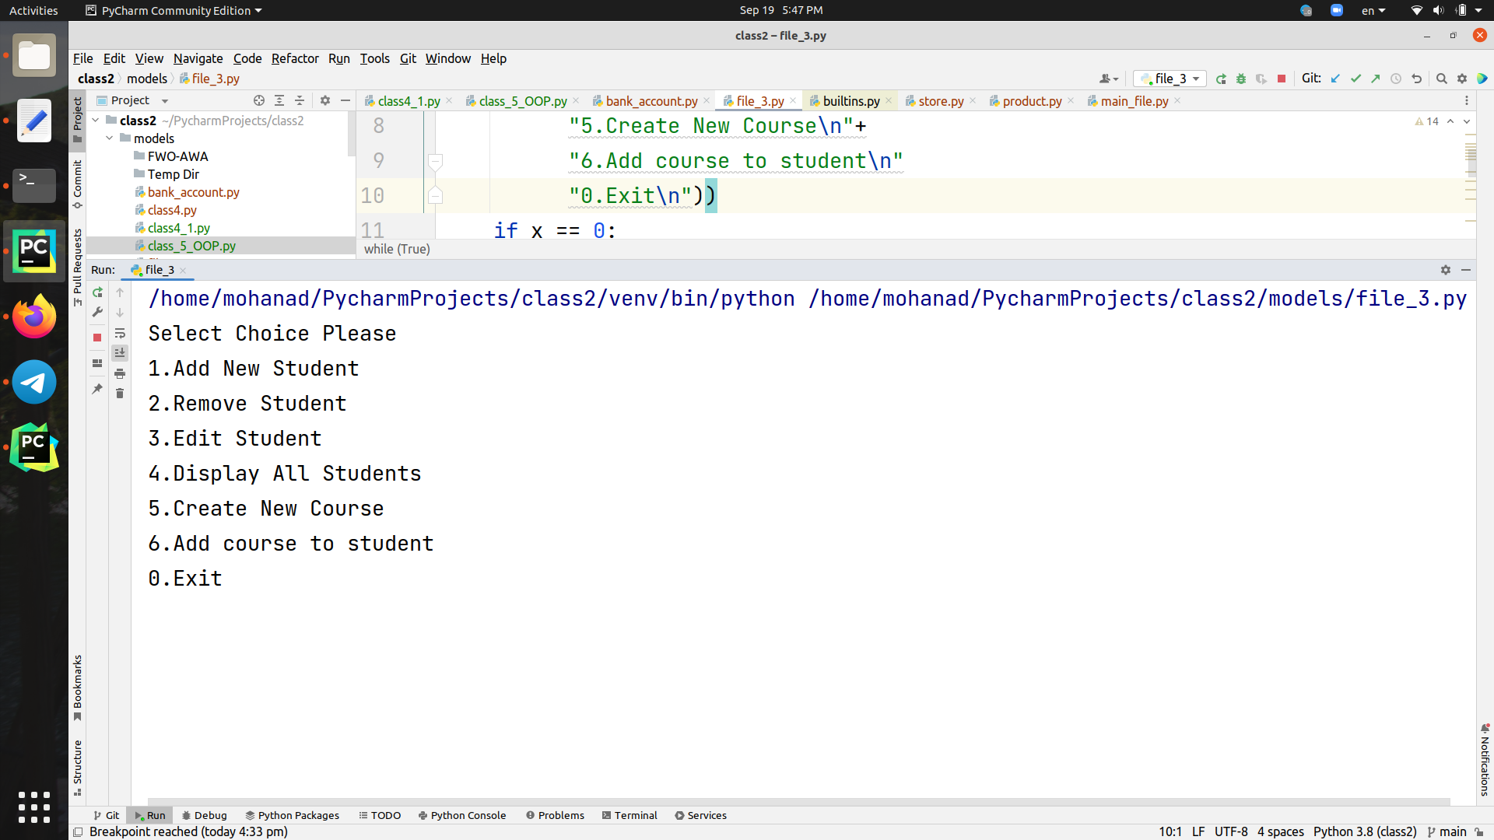

1. **Add New Student**
   * **ask user to enter student name**
   * **ask user to select class(A-B-C)**
     1. **if the input not one of (A-B-C) ask user to select class again**
   * **print student saved successfully**

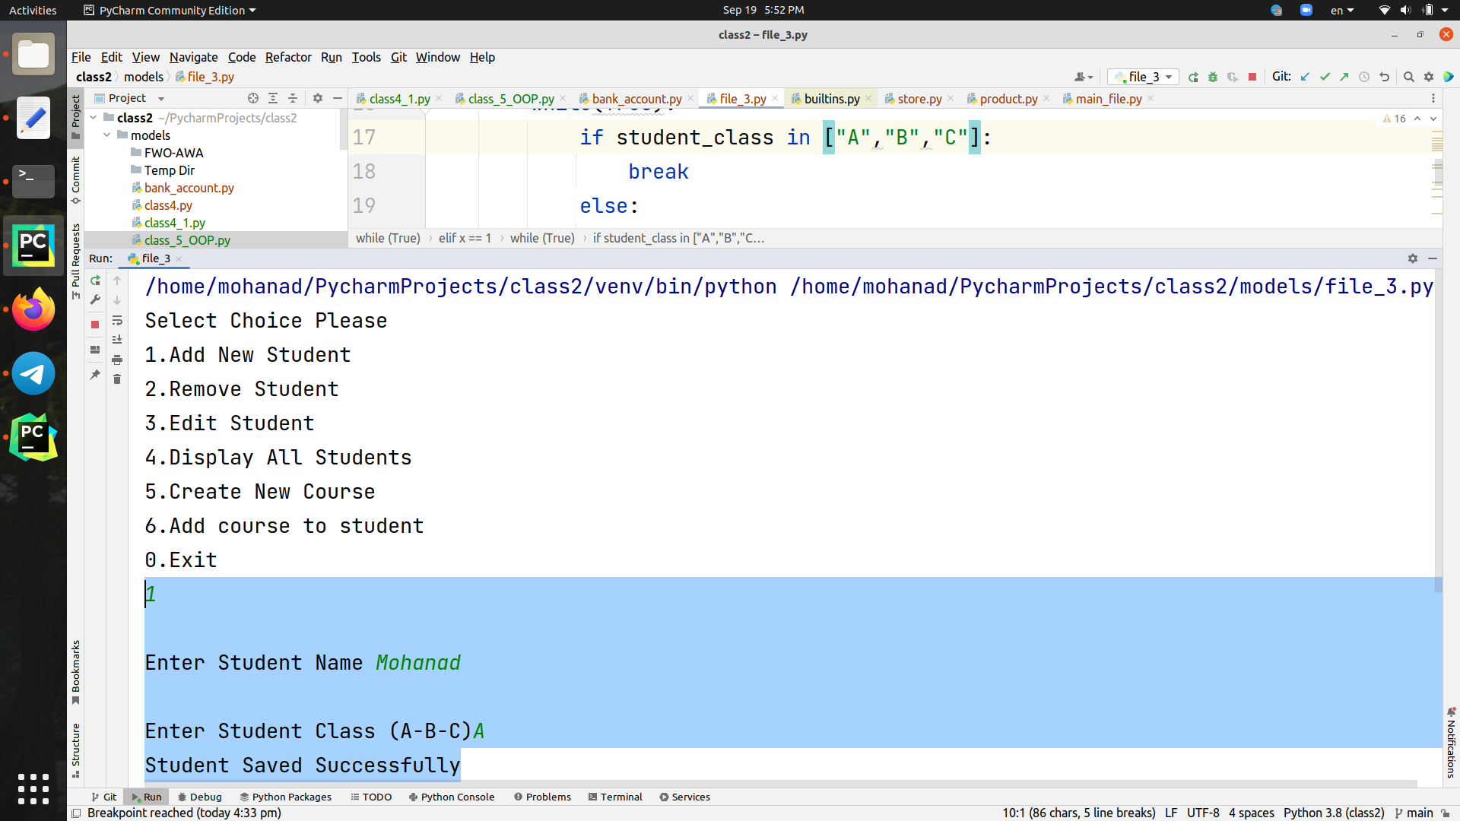

**2 . Remove Student**

* **ask user to enter student id** 
  + **check if the user exist in the system :**
    - **if exist delete student** 
      * **print delete done successful**
    - **if not >> print user not exist**

**3. Edit Student**

* **ask user to enter student id**
  + **check if the user exist in the system :**
    - **if exist** 
      * **ask user to enter new name**
      * **ask user to select new class**
    - **if not exist >> print user not exist**

**4. Display all students**

**5 . Create new user**

* **ask user to enter class name**
* **ask user to select course_class (A-B-C)**

**6 . Add Course to student**

* **ask user to enter student number**
  + **check if student exist or not**
  + **if exist** 
    - **enter course name**
    - **check if course is exist** 
      * **if exist add course to student course list**
      * **if not print >> course not exist**